

Foundations of Programming

Assignment No.: 07
PROBLEM STATEMENT: Write a C program to accept student details and display their result using an array of structures.

OBJECTIVE:

- To understand the concept of structures in C.
- To learn how to store multiple records using an array of structures.
- To accept and process student details such as name, roll number, and marks.
- To calculate total and percentage and display the result.

THEORY:
In C programming, a structure is a user-defined data type that allows grouping of variables of different data types under a single name. When multiple records such as student details need to be stored, an array of structures is used. This allows efficient storage and processing of student information like roll number, name, and marks in different subjects. The program can compute total marks and percentage and display the result for each student.
PLATFORM: Linux
CODE:
#include <stdio.h>

// Define the structure to hold student details
struct Student {
char name[50];
int rollNumber;
float marks[3]; // Assuming 3 subjects for this example
float total;
float percentage;
};

int main() {
int n, i, j;

// Ask the user how many students they want to process
printf("Enter the number of students: ");
scanf("%d", &n);

// Declare an array of structures based on user input
struct Student students[n];

// --- Input Phase ---
printf("\n--- Enter Student Details ---\n");
for(i = 0; i < n; i++) {
printf("\nDetails for Student %d:\n", i + 1);

printf("Name: ");
// The space before %[^\n] tells scanf to ignore leading whitespace/newlines
scanf(" %[^\n]", students[i].name);

printf("Roll Number: ");
scanf("%d", &students[i].rollNumber);

students[i].total = 0; // Initialize total to 0 before adding marks

printf("Enter marks out of 100 for 3 subjects:\n");
for(j = 0; j < 3; j++) {
printf(" Subject %d: ", j + 1);
scanf("%f", &students[i].marks[j]);

// Add the current subject's marks to the total
students[i].total += students[i].marks[j];
}

// Calculate the percentage (Total marks out of 300)
students[i].percentage = (students[i].total / 300.0) * 100;
}

// --- Output Phase ---
printf("\n\n--- Final Student Results ---\n");
printf("------------------------------------------------------------\n");
// %-15s creates left-aligned columns for neat tabular formatting
printf("%-15s %-10s %-10s %-10s\n", "Name", "Roll No", "Total", "Percentage");
printf("------------------------------------------------------------\n");

for(i = 0; i < n; i++) {
printf("%-15s %-10d %-10.2f %-10.2f%%\n",
students[i].name,
students[i].rollNumber,
students[i].total,
students[i].percentage);
}
printf("------------------------------------------------------------\n");

return 0;
}

INPUT AND OUTPUT:
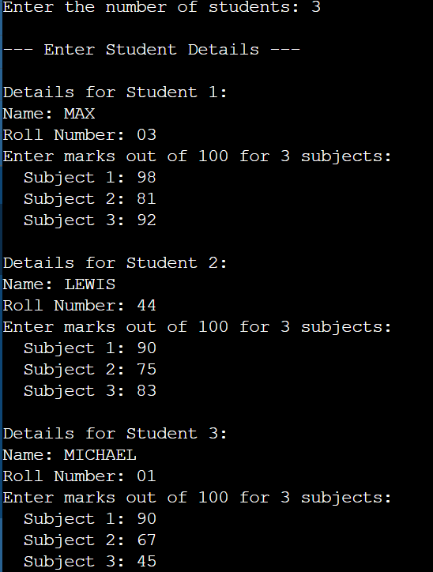
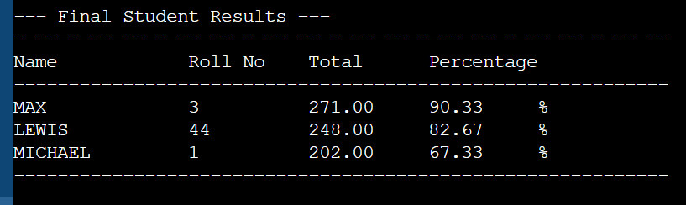

CONCLUSION: Thus, the C program successfully accepts student details using an array of structures and displays the calculated result including total marks and percentage.

